SLE-3: Architectural Design Using Full C4 Model
Introduction to Artificial Intelligence

Class : SY B.Tech CSE (AI & ML)
Student Name : Swalehin Kausar Amin Shaikh
PRN : 25UAM023
Division : A
GitHub Link: https://github.com/s91918551-hue/AI-Agent-Project

1. System Title and Short Description

System Title: BFS and DFS Graph Search and Performance Analysis System

The BFS and DFS Graph Search and Performance Analysis System searches for a goal node in a graph using Breadth-First Search (BFS) and Depth-First Search (DFS). BFS explores nodes level by level using a queue, while DFS explores deeper nodes using a stack or recursion. The system measures execution time and nodes expanded to compare the performance of both algorithms. The C4 model represents the system architecture at four levels.

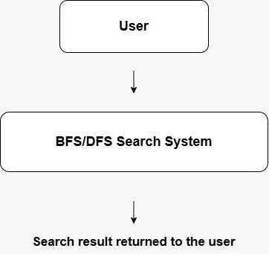

Explanation:

The context diagram shows the interaction between the user and the graph-search system. The user runs the program, and the system performs graph searching using BFS and DFS. The system provides search results and performance information to the user.

3. Container Diagram — Level 2

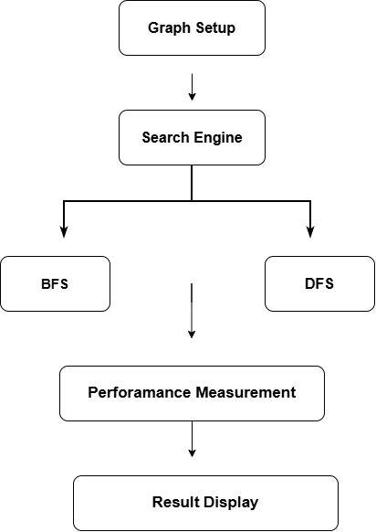

Explanation:

1. Graph Setup: Stores graph data, the start node and the goal node.
2. Search Engine: Executes the BFS and DFS algorithms.
3. Performance Measurement: Measures execution time and records nodes expanded.
4. Results Output: Displays search results and performance measurements.
These represent the main logical parts of the program.

4. Component Diagram — Level 3

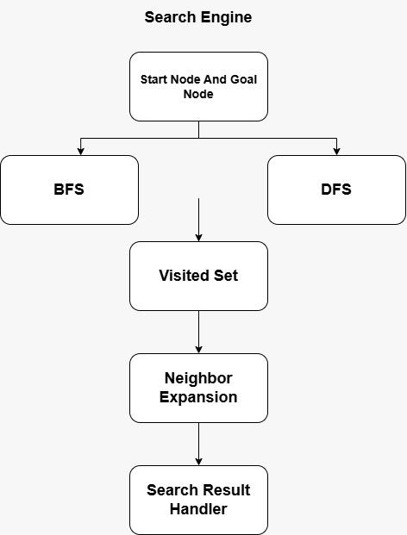

Explanation:

The component diagram represents the internal structure of the Search Engine. The BFS function uses a queue, while the DFS function uses a stack or recursion. Neighbor exploration checks connected nodes. The visited set tracks explored nodes, and the goal check determines whether the target node has been found.

5. Code-Level Overview — Level 4

Main Code Elements:

1. "Graph" — Stores graph data.
2. "BFS(graph, start, goal)" — Performs Breadth-First Search.
3. "DFS(graph, start, goal)" — Performs Depth-First Search.
4. "Visited" — Tracks visited nodes.
5. "Measure_Algorithm()" — Measures algorithm performance, if present in the project code.

Explanation:

The code-level overview identifies the main data structures and functions used in the project. The graph stores nodes and connections, BFS and DFS perform graph searching, and the visited set tracks explored nodes. The measurement function evaluates algorithm performance.

6. Design Decisions

1. BFS and DFS are selected to compare two graph-search strategies.
2. BFS uses a queue, whereas DFS uses a stack or recursion.
3. A visited set helps avoid repeatedly exploring nodes.
4. Execution time and nodes expanded are used for performance comparison.

7. AI Contribution Note

What AI Helped With: Understanding the C4 model, organizing the architecture documentation and explaining the diagrams.

What I Did Myself: Studied the project code, reviewed the search algorithms, prepared the diagrams and checked the final documentation.

8. Conclusion

The C4 model provides a structured representation of the BFS and DFS Graph Search and Performance Analysis System. The context diagram shows the system's interaction with the user, the container diagram presents its main logical parts, the component diagram explains the Search Engine, and the code-level overview identifies important functions and data structures. This documentation helps explain the system architecture clearly.

